# API Specification Document

## Weather API

For the weather API, I used the <https://www.weather.gov/documentation/services-web-api>. After clicking the link on the home page, navigate to the Examples tab,

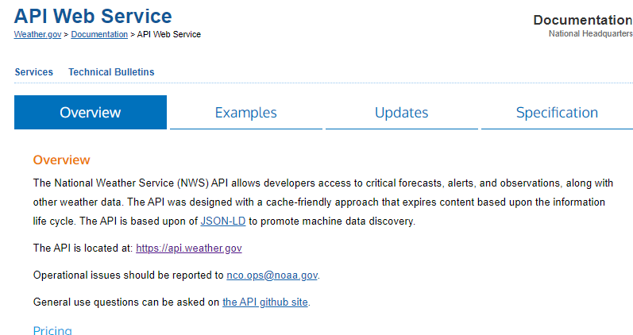

In the Examples tab, I copied and pasted the outlined text in a Jupiter Notebook to display data.

## Event Booking API

For the Event Booking API, I used the SeatGeek Platform. I ran into some difficulties with authentication. I created a new user for the API and gained a Client ID, and a Secret ID, or API Key. However, I was unable to call any data from the API using the instructions provided in the API.